Project Name: e-quarz

FRD(Functional Requirement Document)

Version:13.0

Date:[ [12-aug-2023 to 20-oct-2023]

* Table of Contents:

1. Introduction
2. User management:
   1. User Registration
   2. User authentication
   3. User Profile
3. Product management:
   1. Product listings
   2. Product Search and Filters
   3. Product Reviews and Ratings
   4. Shopping Cart
   5. Check out
4. Order management:
   1. order history
   2. order tracking
   3. order cancellation and return
5. Admin Panel:
   1. user management
   2. product management
   3. order management
6. security and privacy:
   1. ssl encryption
   2. user data protection
   3. payment security
7. notification :
   1. email notification
   2. In-app notification
8. Performance:
   1. loading speed
   2. scalability
9. mobile responsiveness:
   1. mobile optimization
10. Reporting and Analytics:
    1. sales analytics
    2. user analytics
    3. compliance:

* legal compliance
* accessibility
* documentation
* technical documentation

1. Appendices:
2. Introduction:

* This Functional Requirement Report outlines the specifications and features of an e-commerce website to provide a comprehensive platform for buying and selling products online. The e-commerce website aims to ensure a seamless shopping experience for customers while offering efficient management tools for the website administrators and sellers.

1. User Management:
   1. User Registration:

* Users should be able to create accounts with personal information.
* Optional social media login functionality for quicker registration.

2.2 User Authentication:

* Secure login with email/username and password.
* "Forgot Password" feature for password reset.

2.3 User Profiles:

* Users can edit and update their profiles.
* Profile pictures and contact information are included.

1. Product Management:

3.1 Product Listings:

* Sellers can add new products with details such as title, description, price, and images.
* Products can be categorized and tagged for easier searching.

3.2 Product Search and Filters:

* Users can search for products by keyword, category, price range, and other filters.

3.3 Product Reviews and Ratings:

* Customers can leave reviews and ratings for products.
* Average ratings displayed for each product.

3.4 Shopping Cart:

* Users can add products to their shopping cart.
* Cart should display the total cost and allow for quantity adjustments.
  1. Checkout:
* Secure payment gateway integration for online transactions.
* Multiple payment options, including credit/debit cards, PayPal, and others.

1. Order Management.
   1. Order History:

* Users can view their order history with order status.
  1. Order Tracking:
* Real-time order tracking and notifications.
  1. Order Cancellation and Returns:
* Users can request order cancellations and returns.
* Admin can process and track returns.

1. Admin Panel:

5.1 User Management:

* Admins can manage user accounts, including suspension and approval.

5.2 Product Management:

* Admins can edit, delete, or add products.
* Inventory management and stock tracking.

5.3 Order Management:

* View, process, and manage orders.
* Handle returns and cancellations.

1. Security and Privacy:
   1. SSL Encryption:

* Secure Sockets Layer (SSL) to protect data during transmission.
  1. User Data Protection:
* Compliance with data protection regulations (e.g., GDPR).
* Secure storage of user information.
  1. Payment Security:
* Compliance with Payment Card Industry Data Security Standard (PCI DSS).
* Secure payment processing.

1. Notifications:
   1. Email Notifications:

* Users receive order confirmations, shipping notifications, and updates via email.
  1. In-App Notifications:
* Real-time updates and alerts within the website.

1. Performance:
   1. Loading Speed:

* Fast loading times to enhance the user experience.
  1. Scalability:
* The website should be able to handle increased traffic during peak periods.

1. Mobile Responsiveness:

9.1 Mobile Optimization:

* The website should be accessible and user-friendly on various mobile devices.

1. Reporting and Analytics:

10.1 Sales Analytics:

* Generate reports on sales trends, revenue, and popular products.

10.2 User Analytics:

* Collect user data to understand user behavior and preferences.

10.3 Compliance:

* Legal Compliance:
  + Comply with local, national, and international e-commerce regulations.
  + Accessibility:
  + Ensure that the website is accessible to people with disabilities.
* Documentation:
* User Manuals
  + Provide user manuals for both customers and administrators.
* Technical Documentation:
  + Document the website's architecture and APIs for future maintenance.
* Appendices:

1. Dashboard:

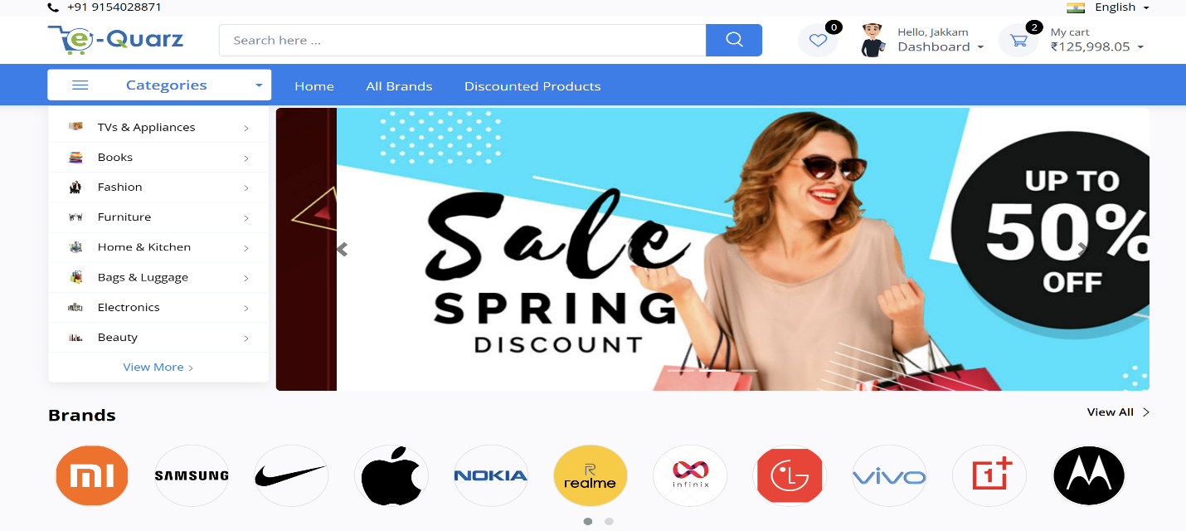

1. Shopping cart:

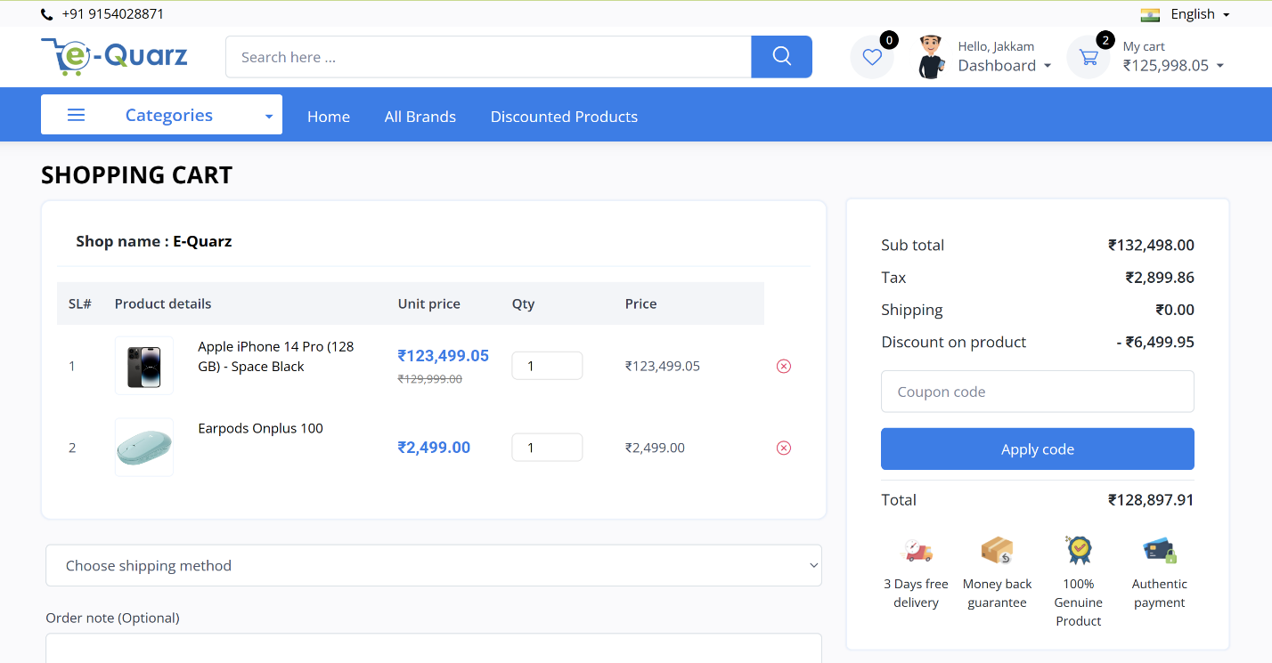

1. My Order:

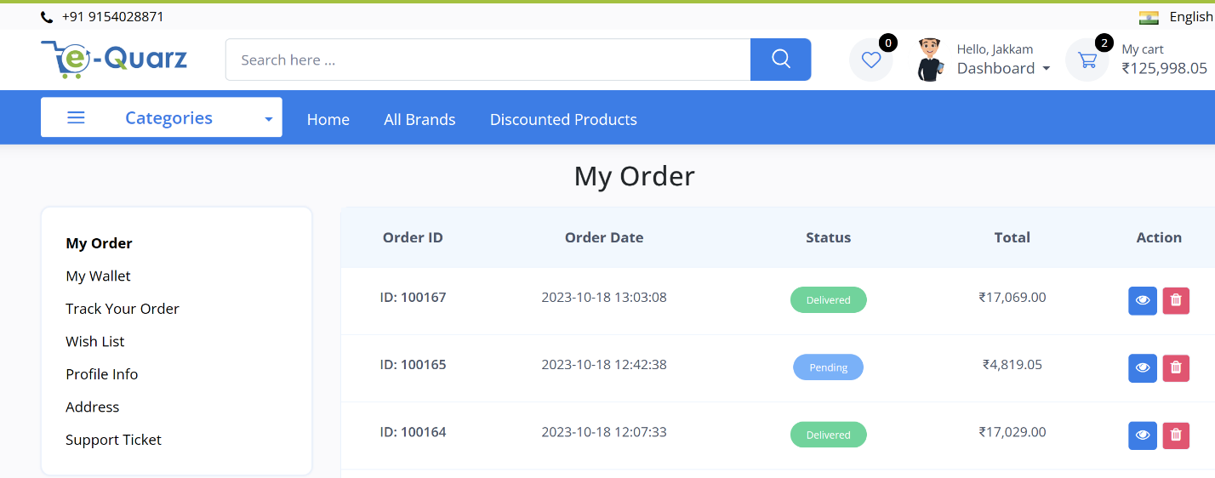

1. Profile Info:

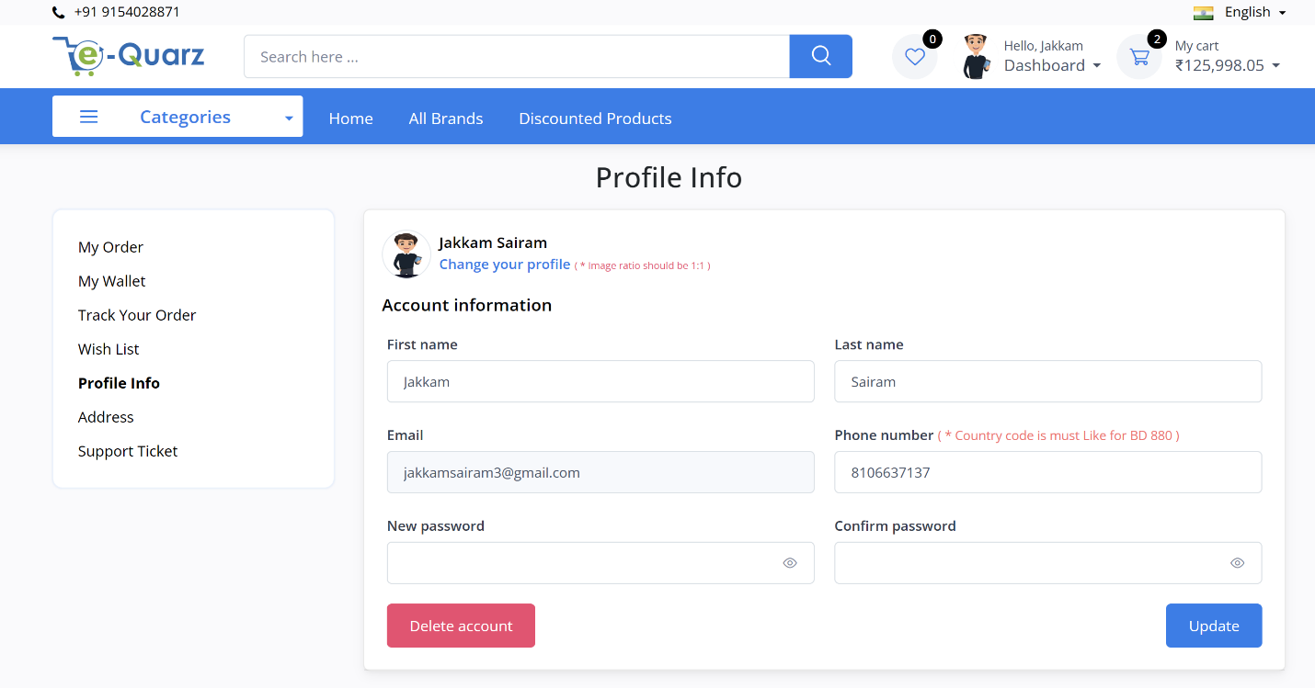

1. Support Ticket:

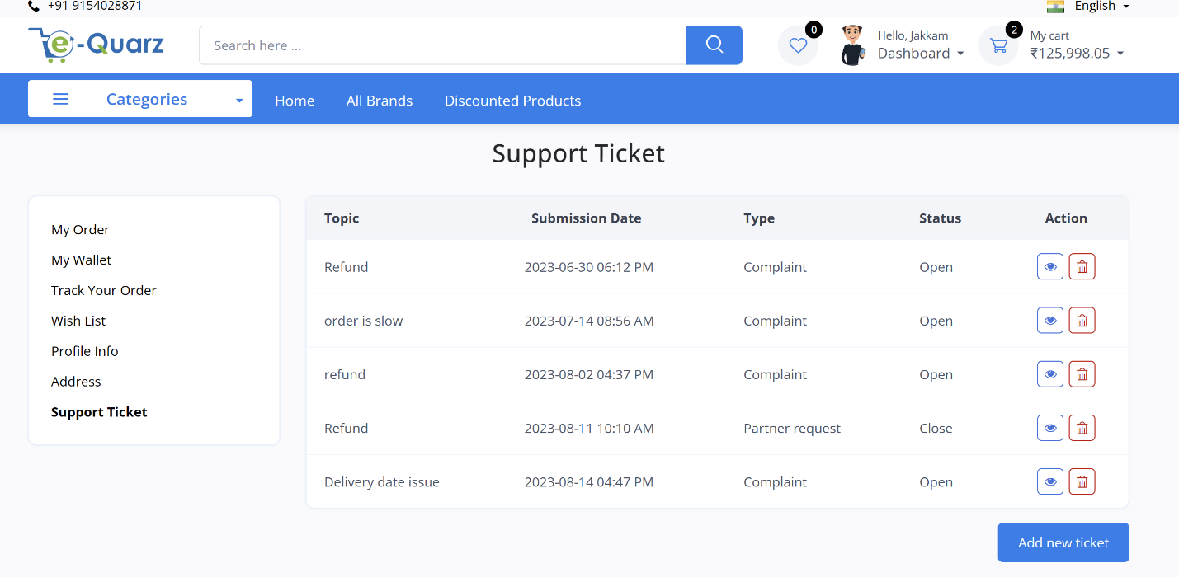

* This BRD is approved by:
* Name: [T Gautam Reddy]
* Title: [Business Analyst]
* Date: [20-oct-2023]